0



American International University- Bangladesh

CSC 3222: Web Technologies

CO1.1 and CO2.1 Evaluation

Project Report

Spring 21-22

Project Title: University Management System

Section: D

Group: 02

|  |  |
| --- | --- |
| Student Name | Student Id |
| Tapu Saha | 19-40152-1 |
| MD. Amimul Ahasun Anas | 19-40149-1 |
| Farhan Hasin | 19-40150-1 |
| SK Mohiuddin Ahmed | 19-40126-1 |

**Introduction:**

The “University Management System” is an improved service,increase information sharing and providing teacher facilities,student facilities and varsity management systems.It can handle all details about a student,faculty and administration.The details include course assign,seat allocation,information of faculties,students.Then comes the management system of the web page and managing the pages. The system will serve the management to reduce cycle times, faster keep track of data, and improve the service, increase information sharing and providing facilities to store information centrally.

**Background Study**

We searched [**www.w3schools.com**](http://www.w3schools.com) to gain more knowledge .Also we searched [**www.php.net/docs.php**](http://www.php.net/docs.php) to know more about php.These things help us to complete our mid project properly.

**Requirement Analysis:**

1. User Category:

There are 4 types of Users here. They are:

* Administration
* University management
* Faculty
* Student

1. Feature List:

**Common features for all:**

* All users can login to the system
* They can manipulate their profile information
* They can change their password

In this project the “User Type 1” (**Administration Functionality**) has the following features: **(Farhan Hasin)**

* Feature 1: Can set passwords for all
* Feature 2: Can view faculty member’s information
* Feature 3: Can update information about faculty
* Feature 4: Can view student’s information
* Feature 5: Can update student’s information.
* Feature 6: Can delete faculty’s information
* Feature 7: Can delete student’s information
* Feature 8: Can give important notice
* Feature 9: Can handle registration
* Feature 10: Can create extra curriculum activities

In this project the “User Type 2” (**University Management Functionality**) has the following features: **(Tapu Saha)**

* Feature 1: Can provide important notices
* Feature 2: Can create new department
* Feature 3: Can view department list
* Feature 4: Assign course to the faculties
* Feature 5: Department wise course views
* Feature 6: Create teacher information
* Feature 7: Room allocation
* Feature 8: View results of students
* Feature 9: Room and class time allocation
* Feature 10: Class schedule

In this project the “User Type 3” (**Faculty Functionality**) has the following features: **(SK Mohiuddin Ahmed)**

* Feature 1: Can give grades
* Feature 2: Can announce class times
* Feature 3: Can upload notices
* Feature 4: Can upload study contents
* Feature 5: Update notes
* Feature 6: Can give extra class schedule
* Feature 7: Can cancel class
* Feature 8: Increase grade
* Feature 9: Decrease grade
* Feature 10: Check student’s CGPA

In this project the “User Type 4” (**Student Functionality**) has the following features: **(MD. Amimul Ahasun Anas)**

* Feature 1: Can check the results and grade
* Feature 2: Can download the study content
* Feature 3: Can check faculty member’s details
* Feature 4: Can do registration
* Feature 5: Can download notes
* Feature 6: Check payment slip
* Feature 7: Can check notices
* Feature 8: Can select courses
* Feature 9: Can select major courses
* Feature 10: Can select minor courses.

**Design:**

Draw an entity diagram of your project here.

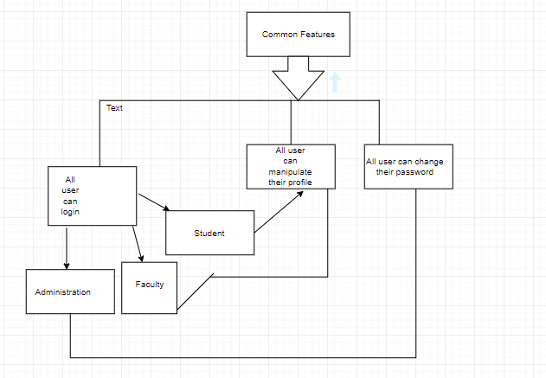

**Tools Used:**

To develop this project, we have used the following:

•Microsoft Word

•Snipping Tool

• PHP

• HTML

• Diagram Editor

• XAMPP

• Visual Studio Code

• Microsoft Edge

• Chrome

**System Images against the Specification:**

Give a screen shot of some GUIs (Midterm project) and write a very small description (Maximum 40 words) for each of the GUIs.

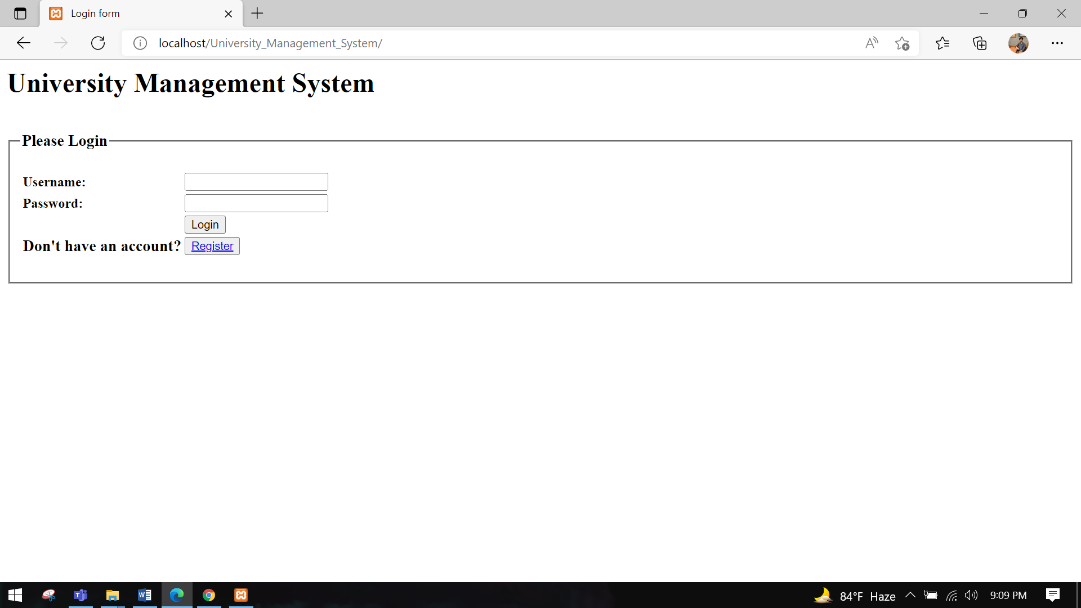

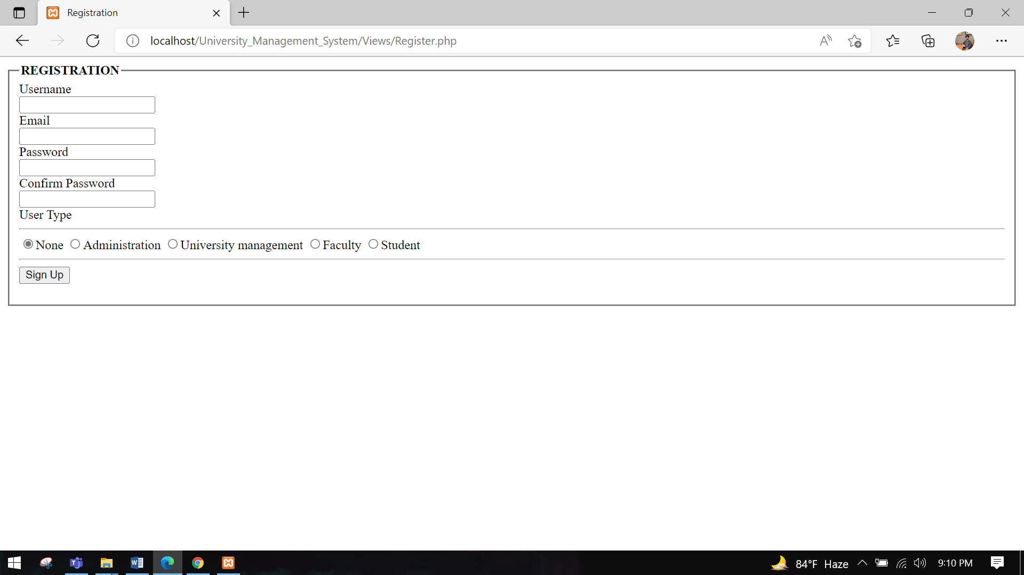

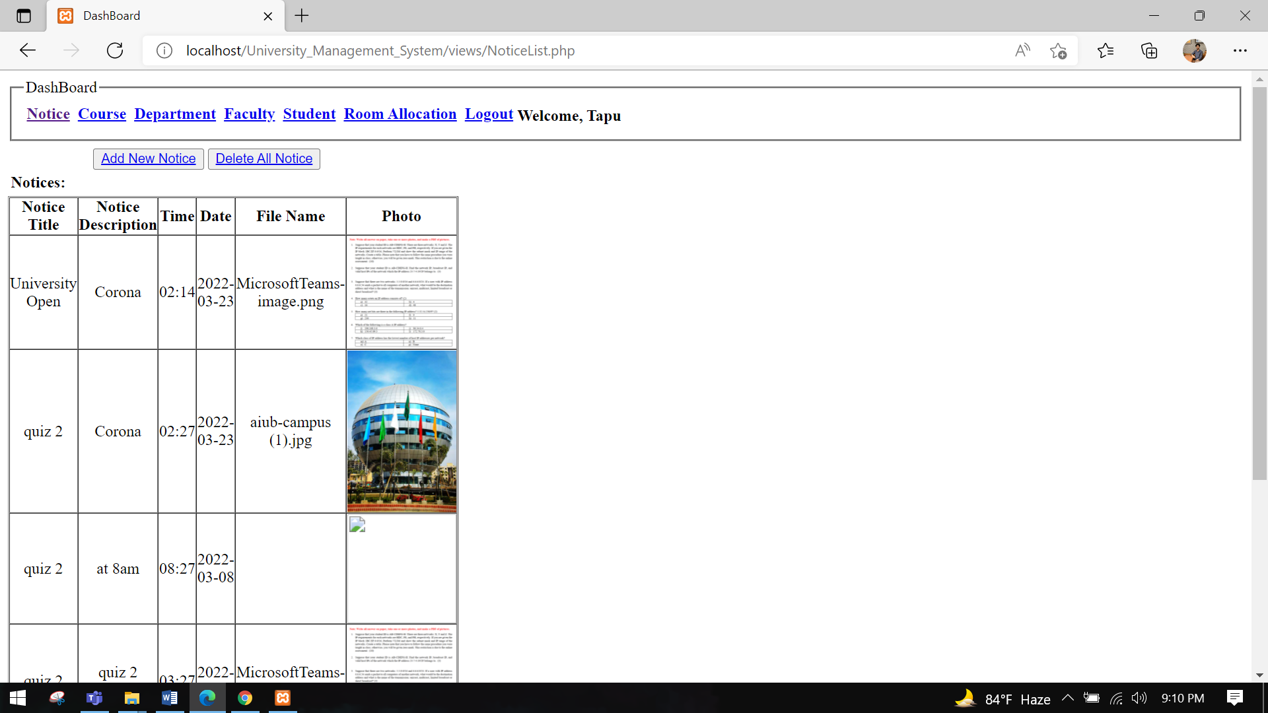

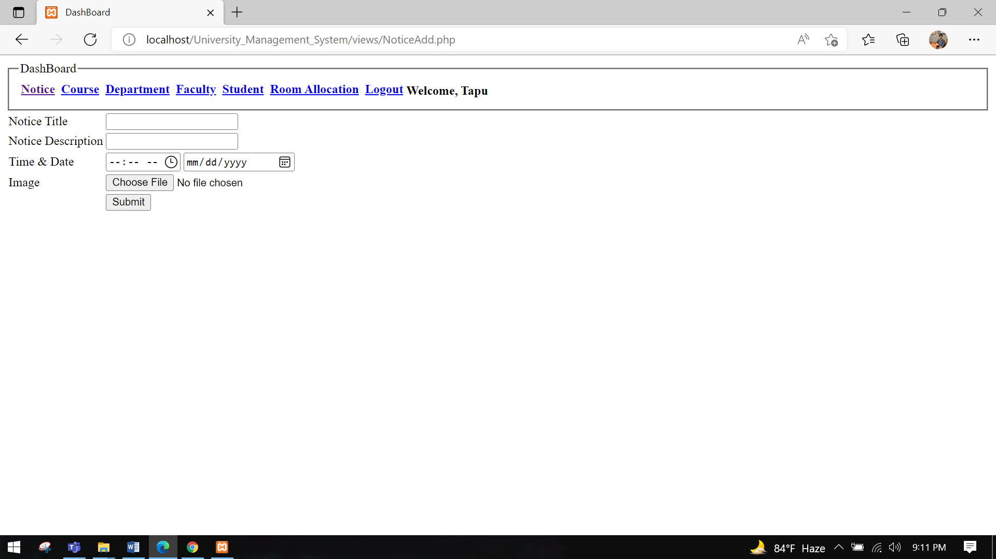

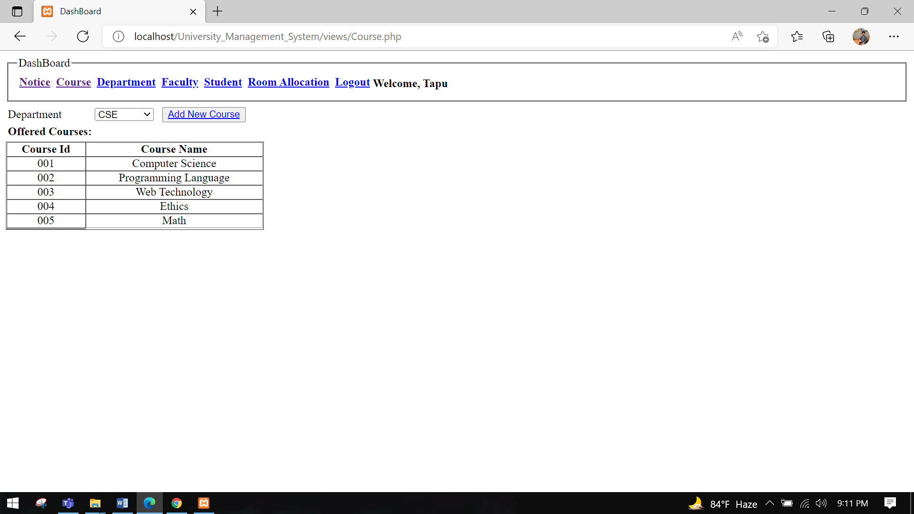

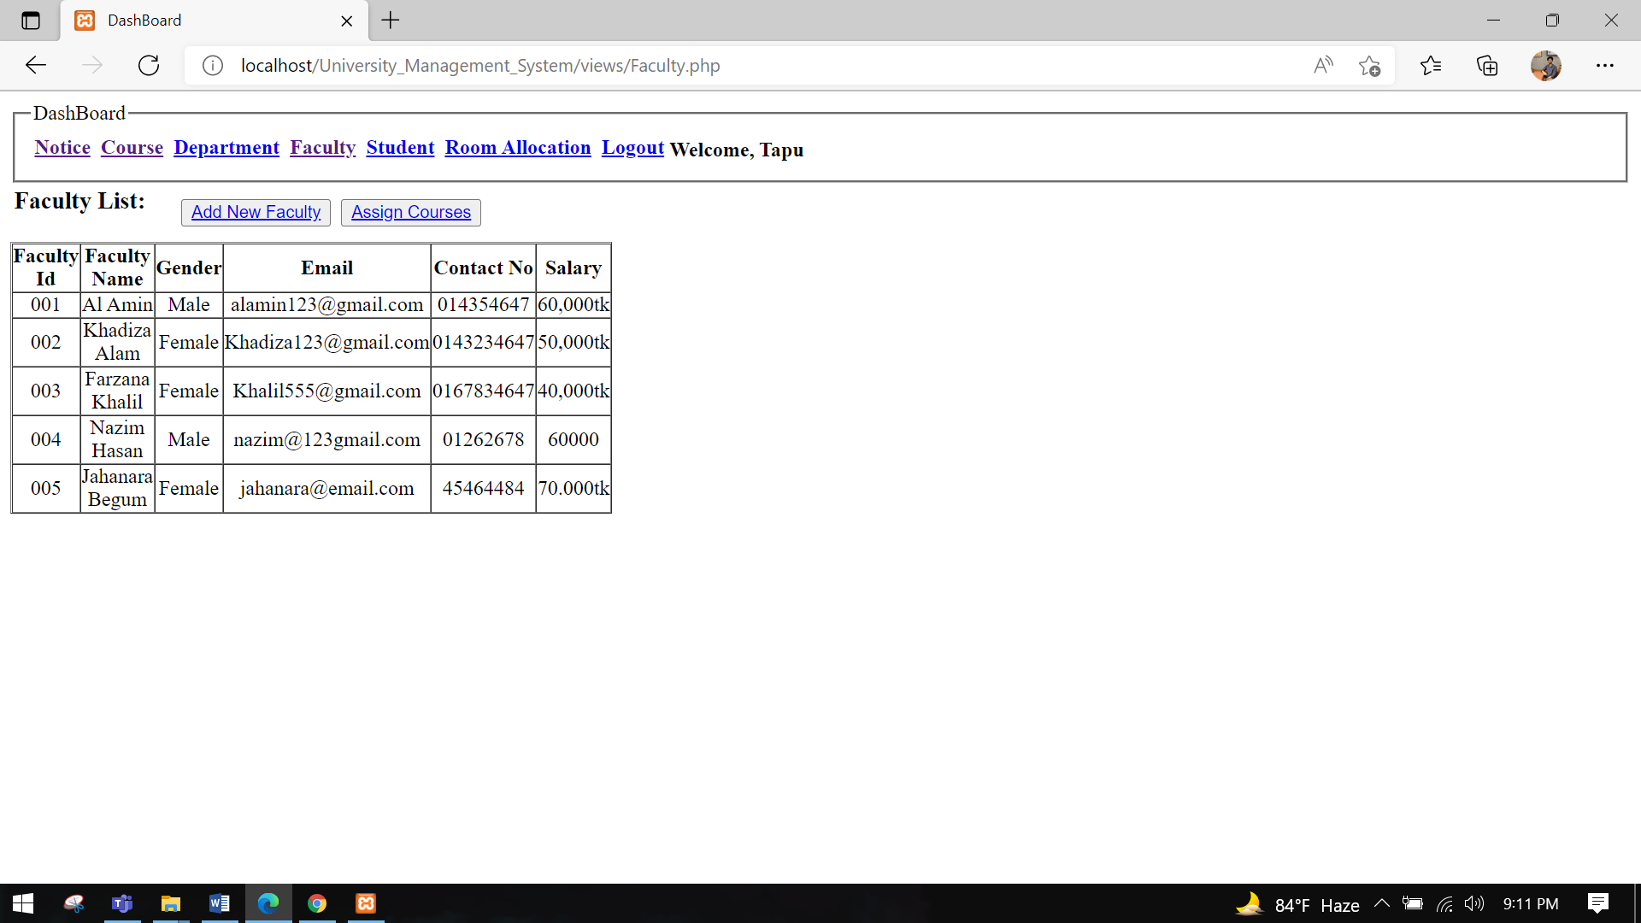

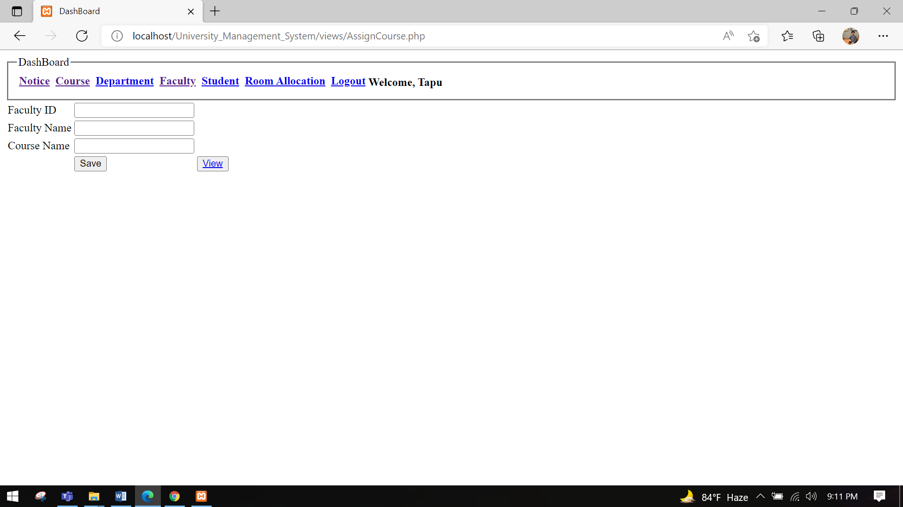

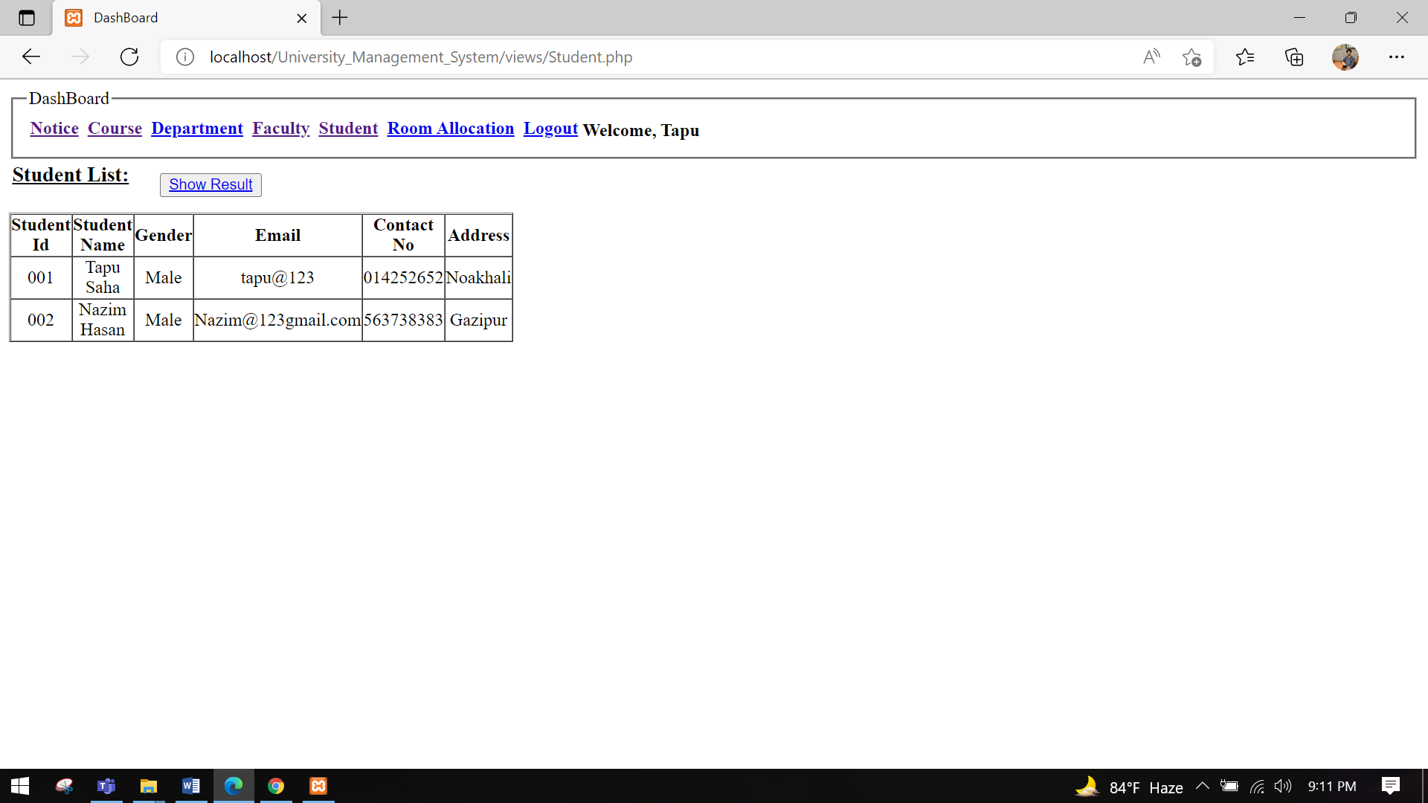

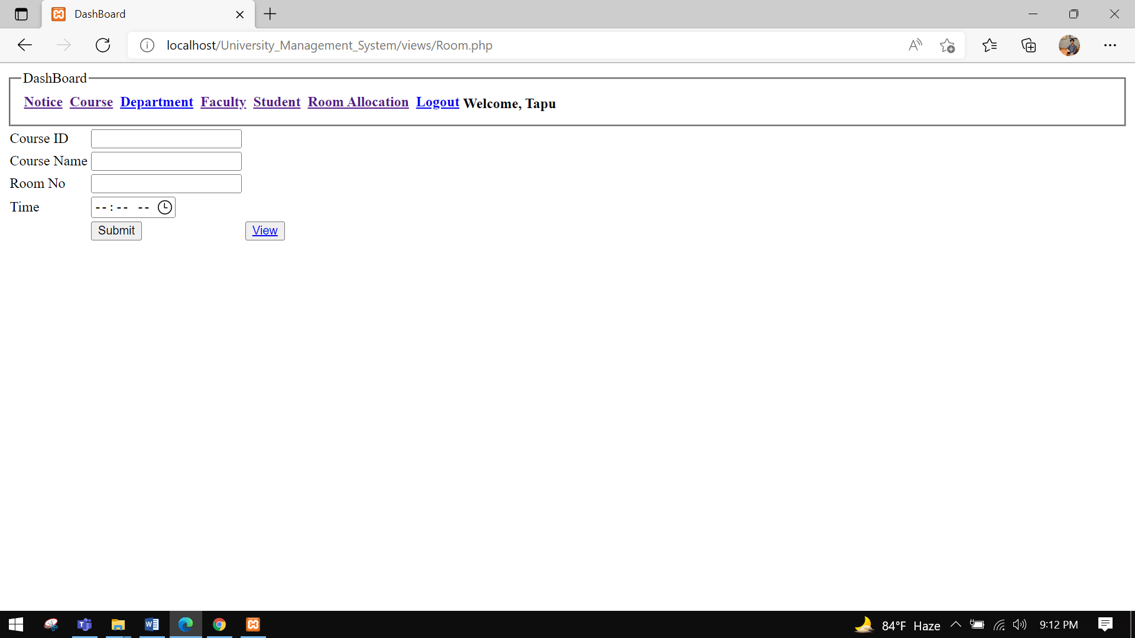

**Impact of this Project:**

Describe the increasing importance of your project on modern society and environment.

How will people be benefitted from your project?(Maximum 80 words)

The system will serve the management to reduce cycle times, faster keep track of data.Now,the Management can easily check all the information and can also update the information.They can easily give a notice now.It will make all the things easier.

Limitations and Possible Future Improvements.

1)The aim of this project is to manage each and every section. Such as every Student, Teacher and Staff. 2)There will be a system for searching information

3)Notification system will be improved.

(Maximum 80 words)

*[Note: Make sure that your report is maximum 10 pages (including cover page). Print (Colored) the report and submit it with spiral bind.]*

|  |  |  |  |  |  |
| --- | --- | --- | --- | --- | --- |
| CO1.1 and CO2.1 Evaluation: Project Report Evaluation | | | | | |
| Project Proposal  (5) | Background  Study  (5) | Requirement Analysis  (5) | Entity  Diagram  (5) | System Images  against the  Specification (5) | Total (25) |
|  |  |  |  |  |  |
|  | | | | | |